

# Analysis Report

**Sameen Fatima**

### 04/10/2022

### —

### Data Analytics

—

Submitted to:

### Sir Misbah Uddin

**Introduction:**

A hardware company named “AtliQ Hardware” provided this data and asked the Data analyst to unlock sales insights in order to take data-driven decisions.

**Stakeholders:**

* Sales director
* Marketing Team
* Customer Service Team

**Objective:**

The goal is to:

* increase sales by 5%.
* 10% cost savings of total Spend.

**Instrumentation:**

The tools used in this process are:

* MYSQL for Analysis
* Power BI for visualizations

**Entity Relationship Diagram:**

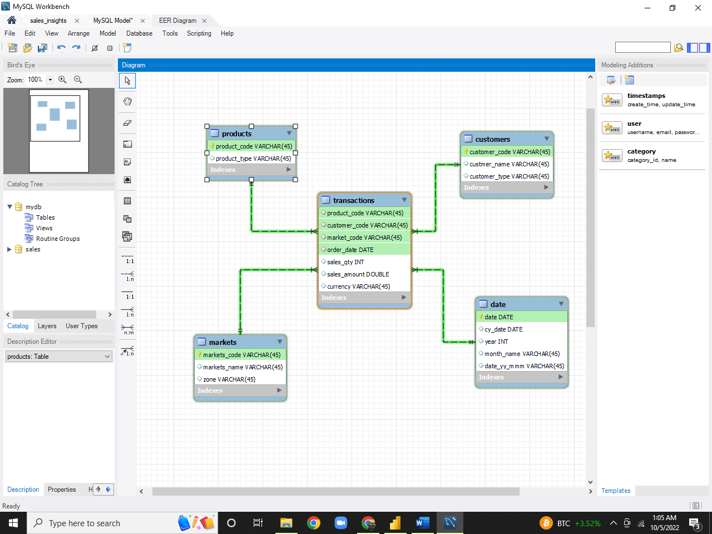

**Methodology:**



**Loading and Analyzing Data in SQL :**

First, I Dumped the data in MySQL Workbench then used SQL to query and analyze my data.



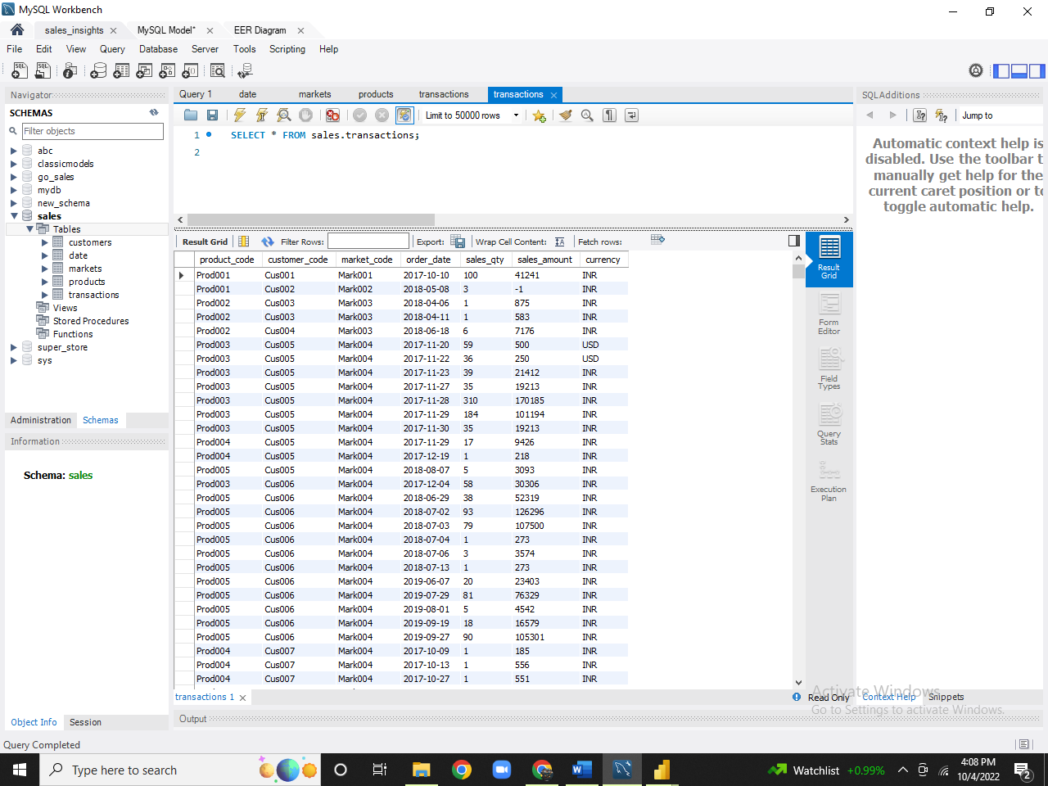



**Data Cleaning in POWER BI**

During analysis, I noticed some negative values in sales column, so I used Power Bi to perform **ETL**. I **Extracted** data from database, **Transformed** it and then **Load** it again.

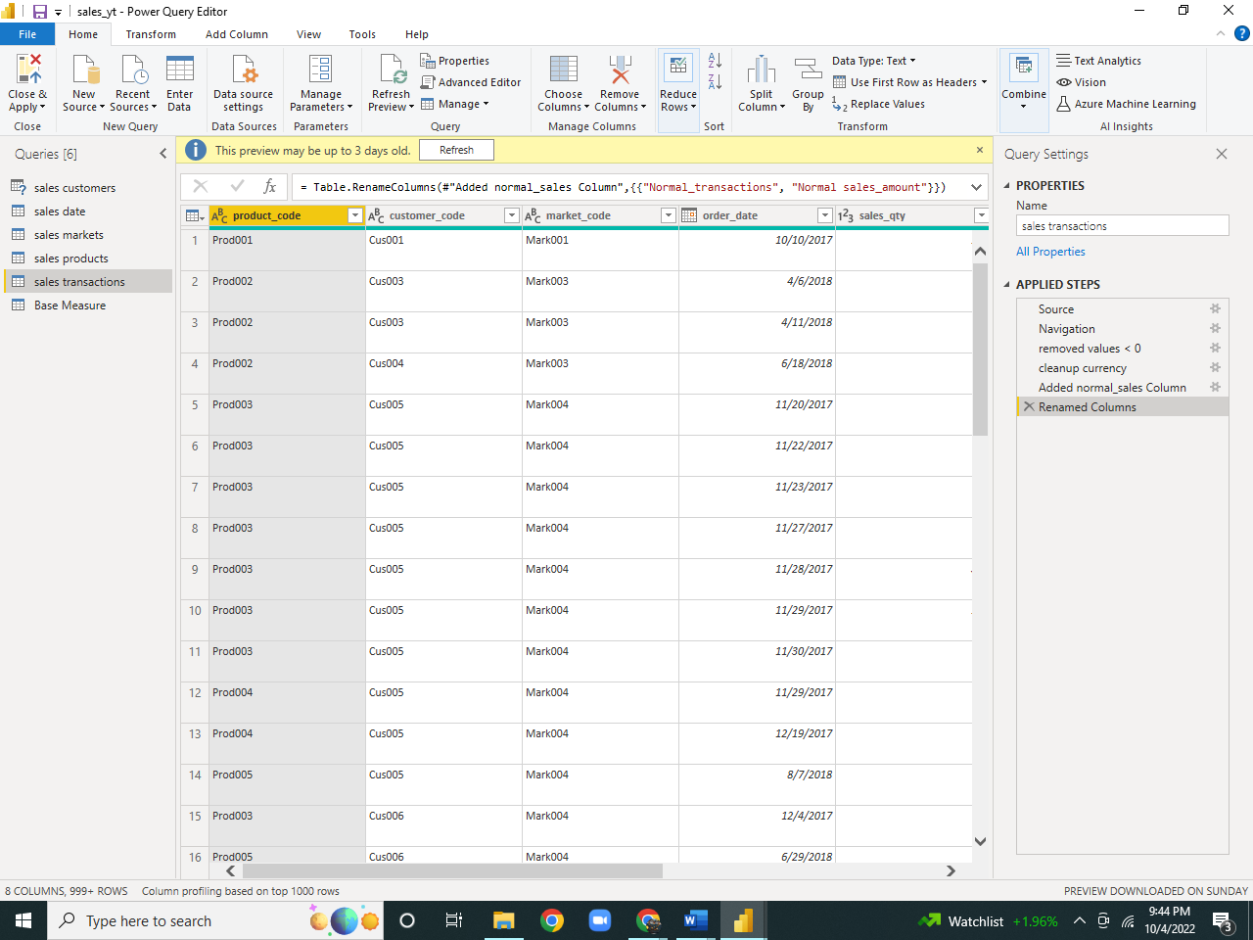

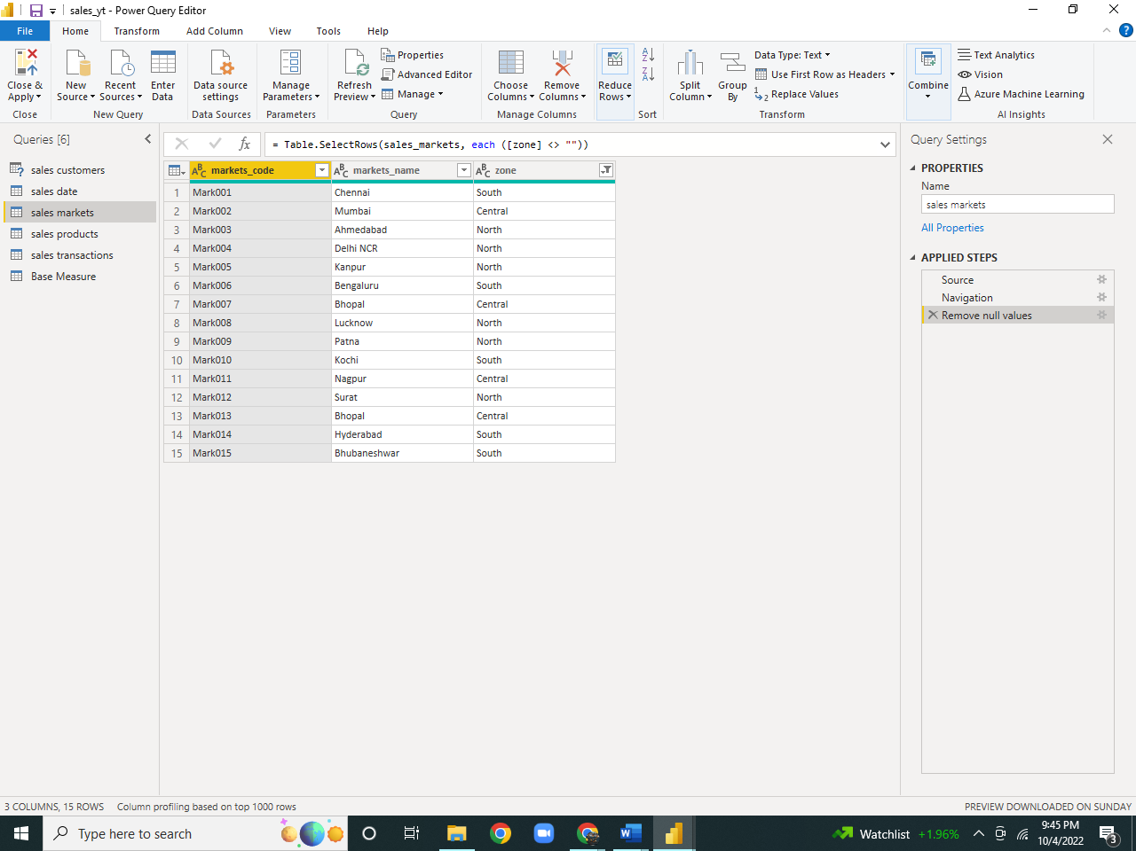

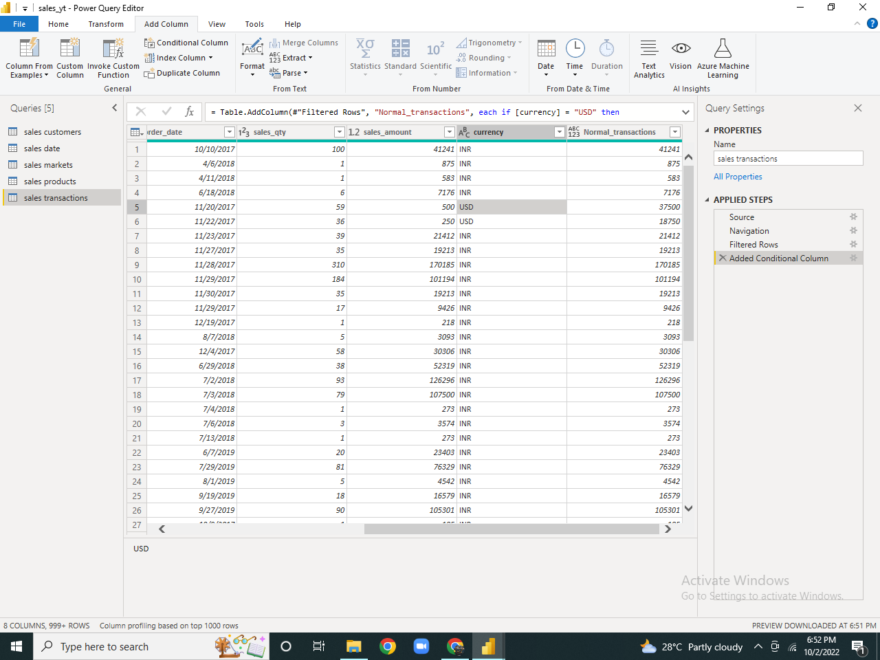

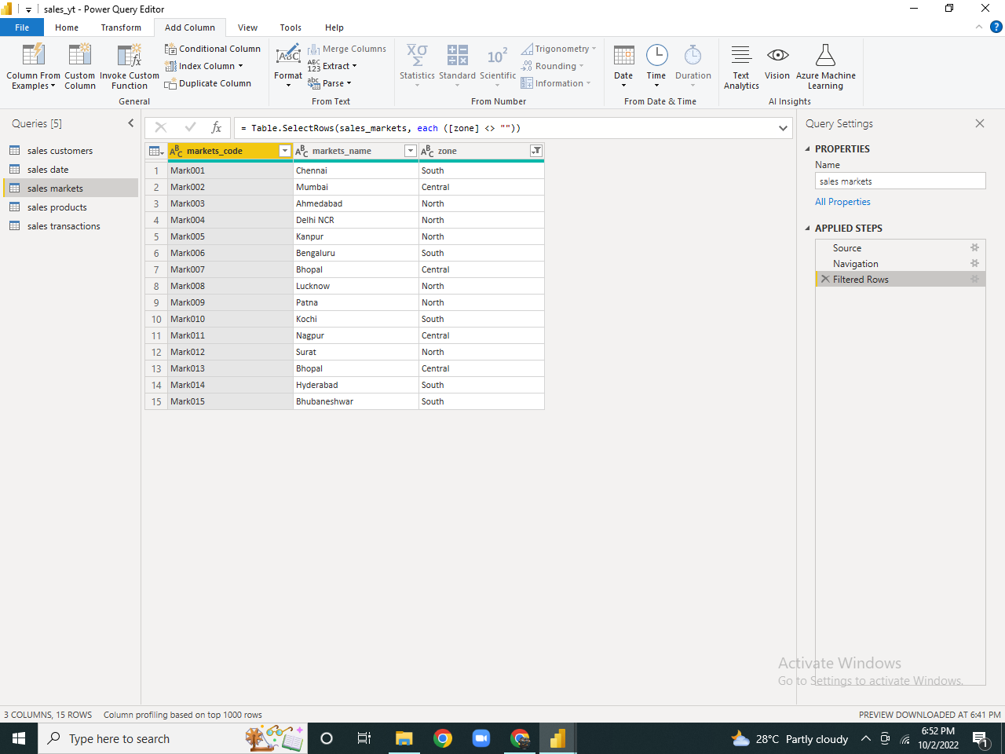

**Creating Measures/ Derived Metrics:**

After Cleaning data, I created Some measures like

* Revenue
* Sales Quantity

**Visualization:**

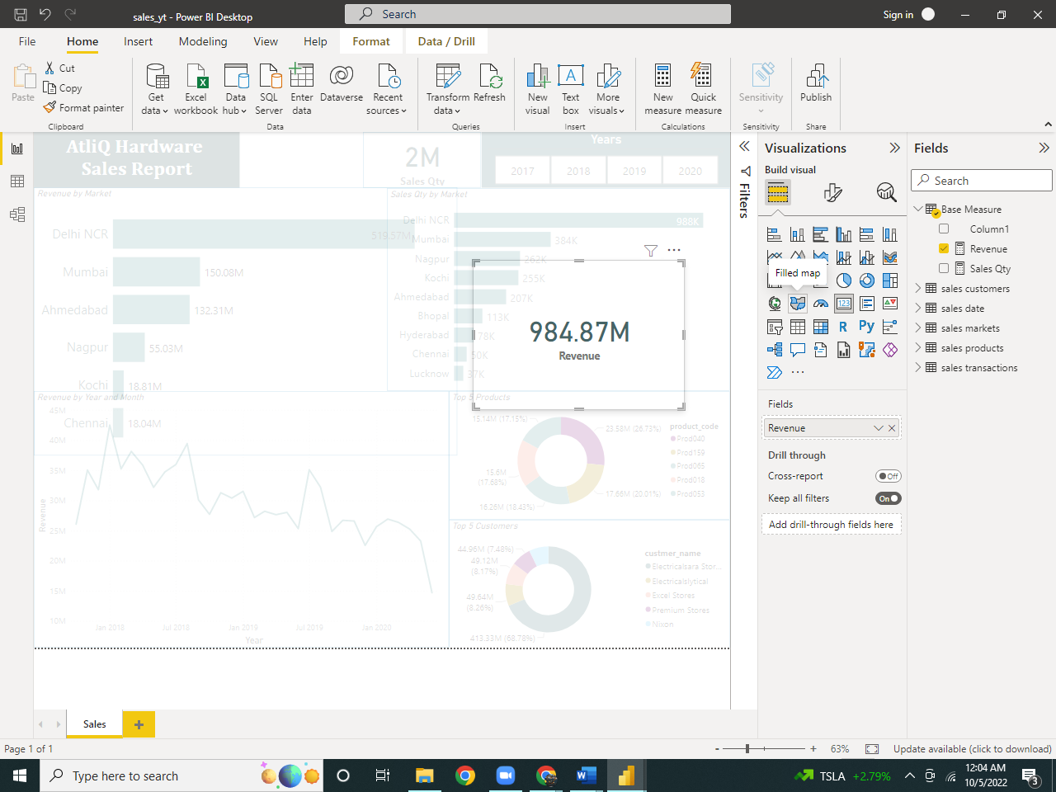Used **cards** to show overall revenue.

Used **clustered Bar chart** to show ‘revenue’ and ‘Sales Quantity’ by Market.

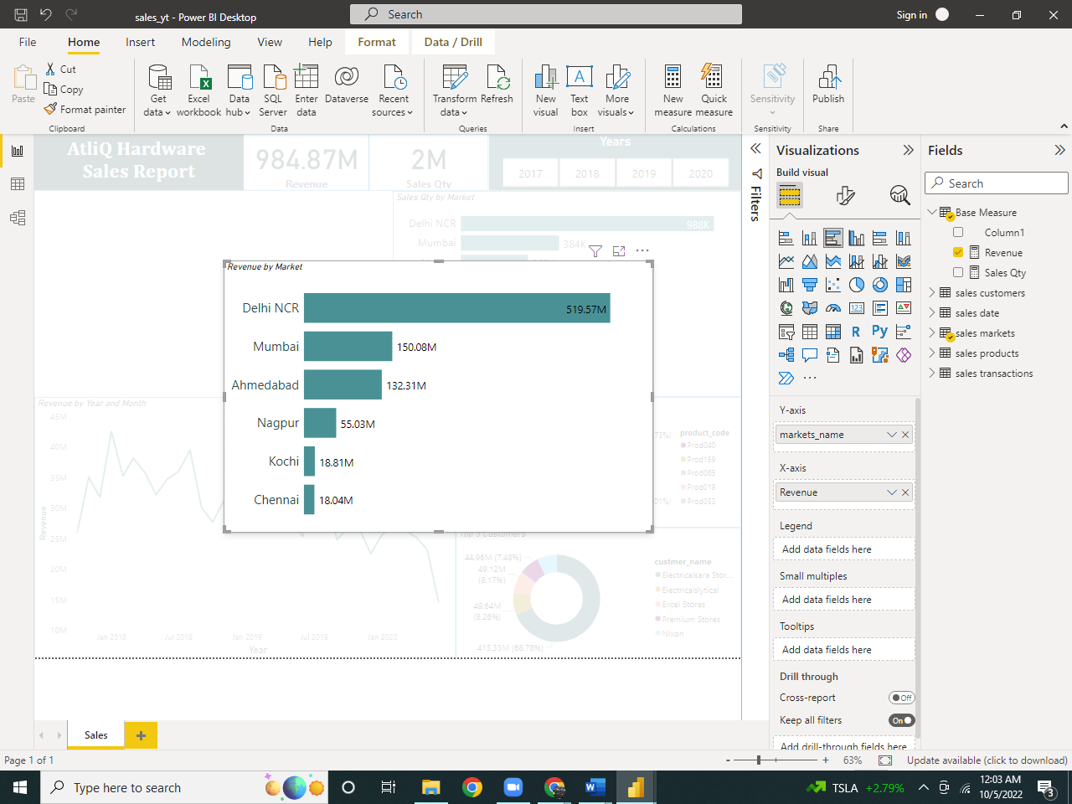Used **Pie chart** to show ‘top customers’ and ‘products’.

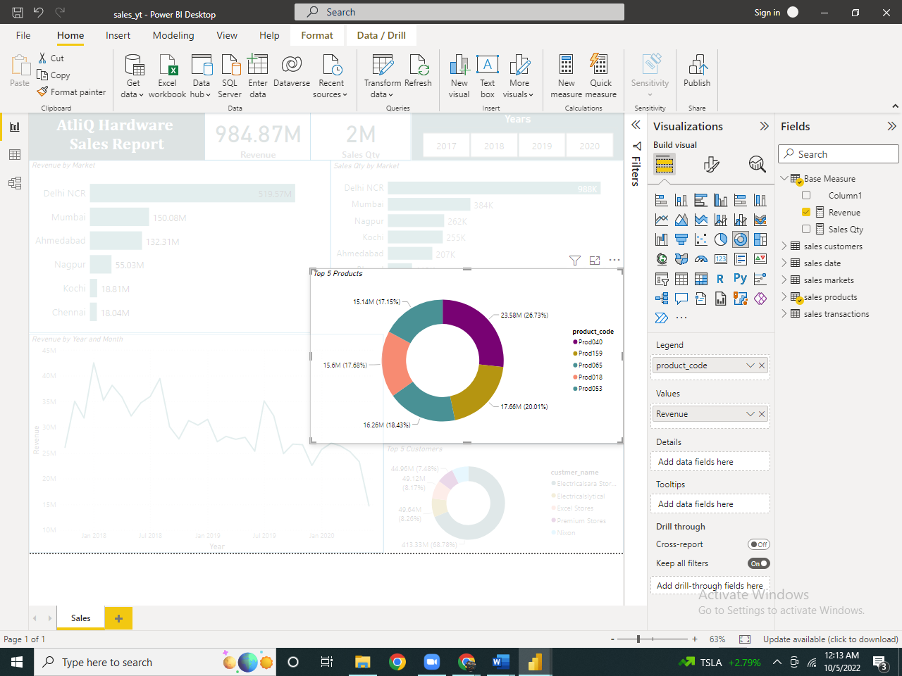

Used **line Chart** to show ‘trends over time’.

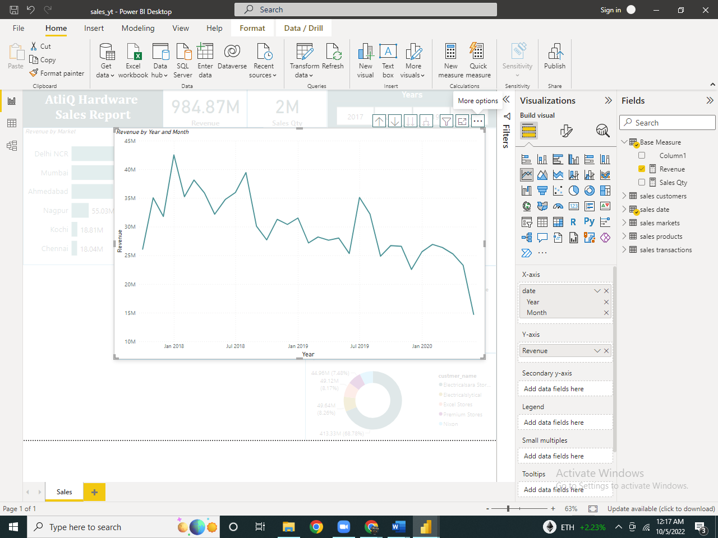

**Thank You!**